**EMCS2010: Applied Cryptography and Data Privacy**

Exercise : Differential Privacy in Action

Brian Russel Davis, [brian_davis@brown.edu](mailto:brian_davis@brown.edu)

With 51 total subjects in the group and **16 that match the query** ( cost of over $1000 ).

The amount of people who match the query would be **31.3 percent.**

Removing one person would lower this query to **29.4.**

So, the difference realized by removing one person is about **2% ( 1.9% more precisely ).**

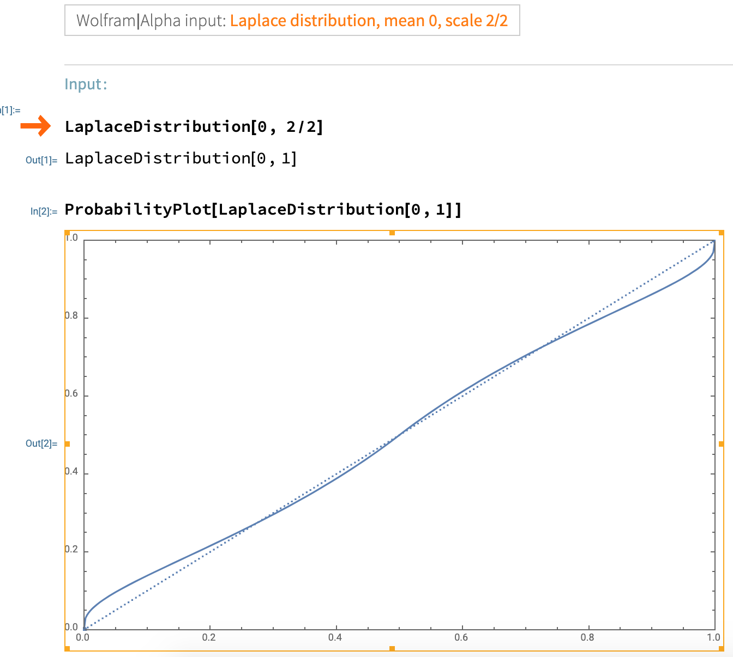

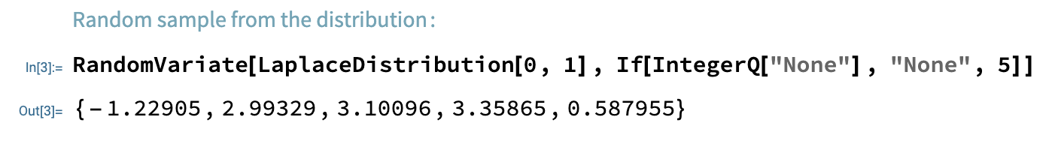

The bigger the epsilon the more inaccurate the answer would be.

*Would the resulting mechanism do a better job of protecting the subjects' privacy or a worse one?*

I am not sure how to answer this. The set of total people is so small in this case ( 51 ). And I don’t agree that any of this affects actual privacy.